Week 2 Internship Documentation
Infosys Springboard Internship | Data Visualization Domain
Topic Focus: Power Query, Data Import, and Basic Data Cleaning in Power BI
Prepared by: Hindu Priya Boddu
Project: Optimizing IT Support Team Performance Using Analytics


1. Introduction
During the second week of the internship, the main focus was on learning Power Query, which is the core data preparation and transformation engine in Power BI. Week 2 built upon the theoretical understanding from Week 1 and moved toward practical data handling. The learning included understanding how to import data from different sources, the difference between loading data directly and transforming data before loading, and the use of essential cleaning tools in Power Query.
This week was highly important because data cleaning and transformation are among the most critical stages of any data analyst project. Before creating visuals and KPIs, the dataset must be made accurate, consistent, and analysis-ready. Power Query provides an efficient, repeatable, and user-friendly interface to perform such tasks.

2. Introduction to Power Query
Power Query is a data connection, transformation, and preparation tool available in Power BI and Excel. It allows users to import data from multiple sources, inspect its structure, clean and transform it, and then load the processed data into the Power BI data model for analysis. Power Query is especially valuable because it supports step-by-step transformations that are automatically recorded in the Applied Steps pane, making the cleaning process transparent, repeatable, and easy to audit.
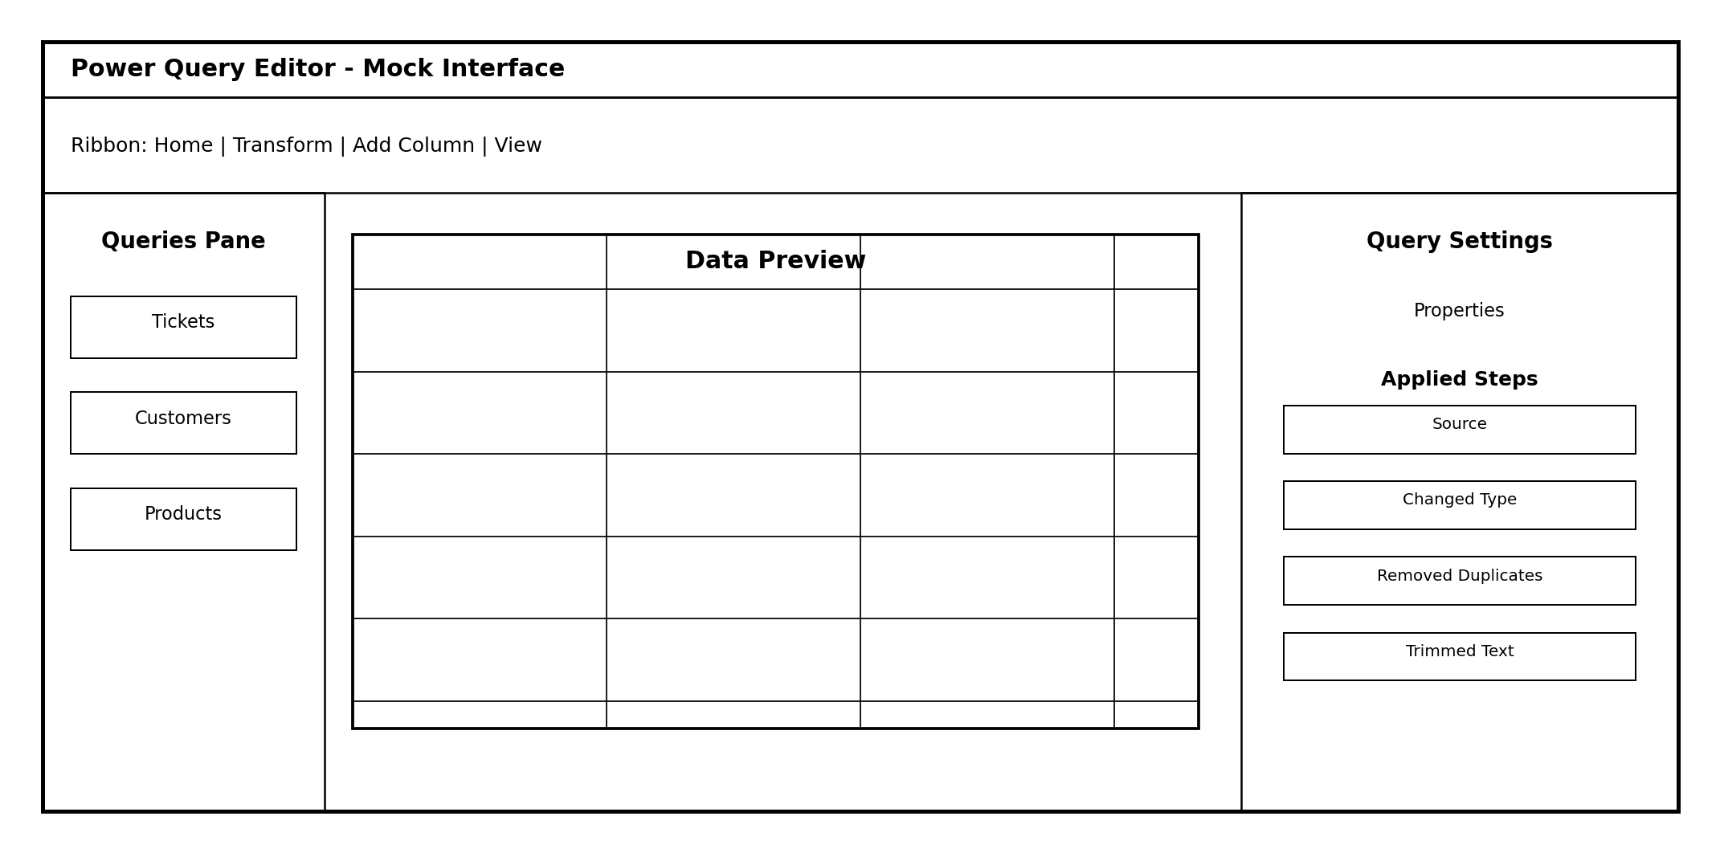
Figure 1: Illustrative mock layout of the Power Query Editor interface
- Used for importing data from multiple sources
- Supports data cleaning before dashboard creation
- Records all changes as sequential transformation steps
- Reduces manual effort by automating repeatable cleaning logic
- Improves reliability and reproducibility of analytics workflows

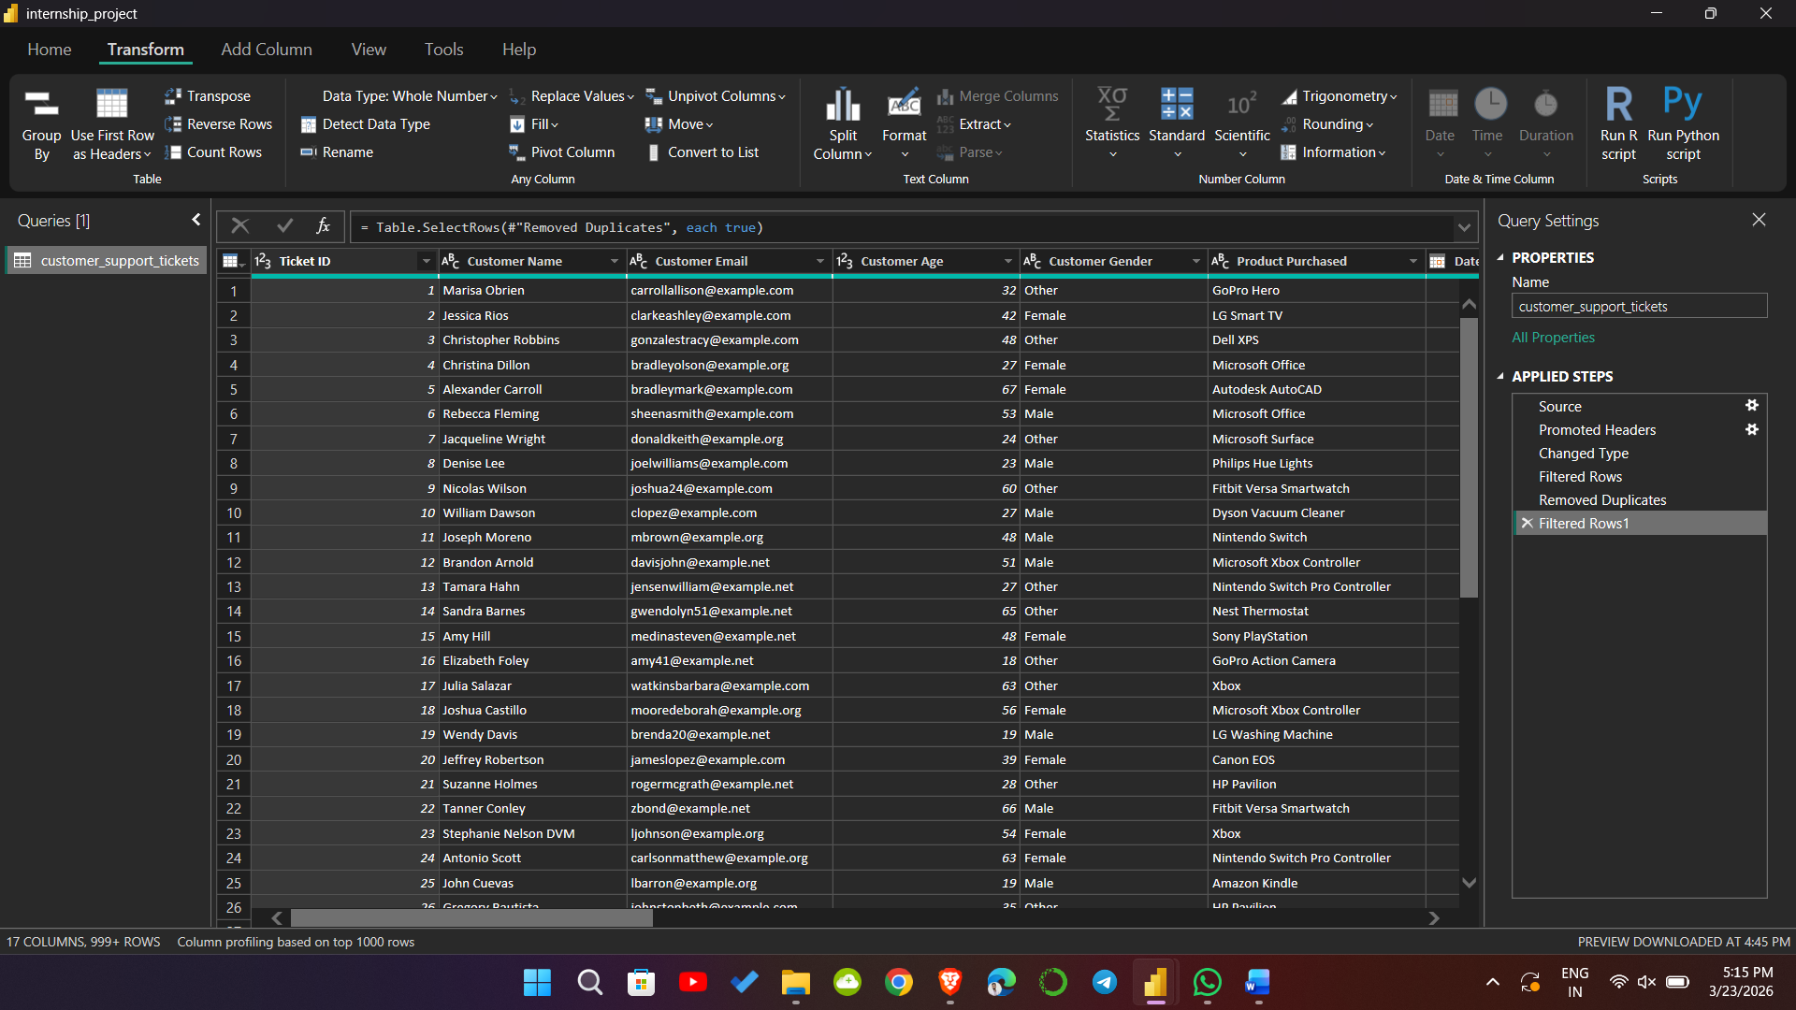
Figure 2: Illustrative layout of the Power Query Editor interface

3. Main Components of Power Query Editor
Component | Purpose
Ribbon | Contains commands for import, transform, add column, remove rows, split column, format, and view options
Queries Pane | Shows all tables/queries imported into the current Power BI file
Data Preview | Displays the selected table for inspection and transformation
Query Settings | Shows properties and all Applied Steps performed on the selected query
Applied Steps | Records each transformation in sequence (e.g., Source, Changed Type, Removed Duplicates)
Formula Bar (optional) | Displays the M code for the selected transformation step
Column Headers | Used for filtering, sorting, renaming, and applying transformations on specific columns

4. Different Methods of Data Import in Power BI
Power BI supports importing data from a wide variety of sources. Understanding the major methods of data import is important because the choice of source affects data quality, refresh capability, transformation effort, and scalability.

Import Method | Description | Importance / Typical Use
Excel Workbook | Import data from .xlsx or .xls files | Most common for beginner projects and internship datasets
CSV / Text File | Import comma-separated or delimited files | Very common for exported system data and raw datasets
Folder | Import multiple files from a folder | Useful when data arrives in multiple monthly files
SQL Server / Database | Connect directly to structured databases | Important in industry for live business data
Web | Import tables or data from URLs | Useful for public datasets or web tables
Enter Data | Create a small manual table inside Power BI | Helpful for lookup tables, small mappings, or test data
SharePoint / OneDrive | Connect cloud-hosted files | Useful in collaborative business environments

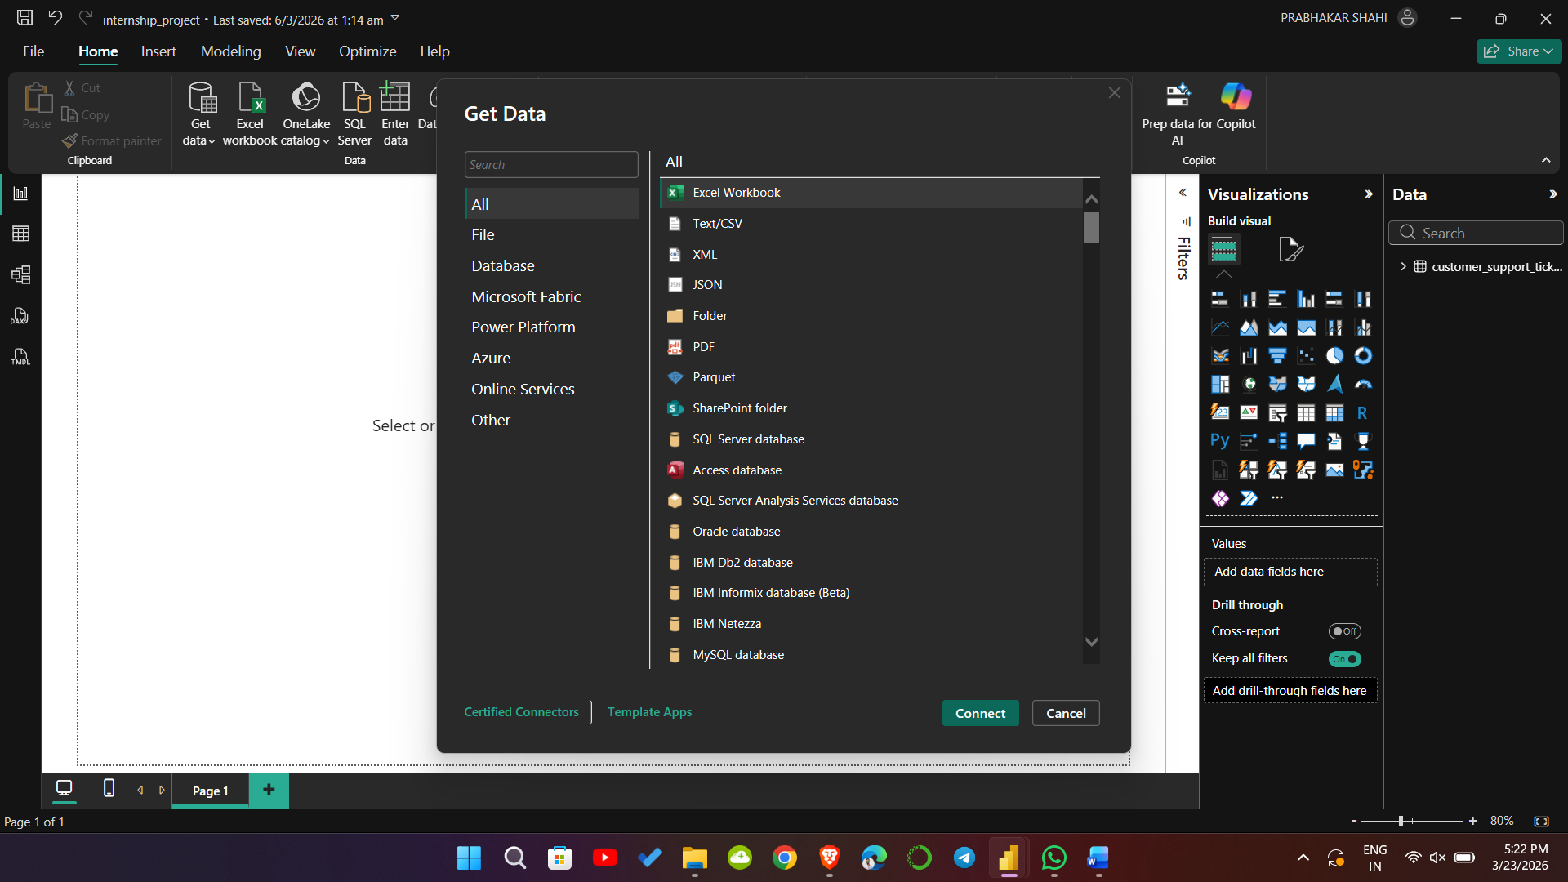
Figure 3: Illustrative different method of import data from Power BI

5. Important Data Import Methods Explained in Detail
- Excel Workbook – Used when data is stored in sheets or structured tables. It is easy to preview and often used for business reports.
- CSV / Text File – Common for raw exported system data. It is lightweight and widely used in datasets downloaded from portals or ticketing systems.
- Folder – Allows combining multiple files with similar structure, such as monthly support ticket reports. This is powerful for automation and scalability.
- Enter Data – Useful when a small dimension table or manual mapping table is needed, such as priority labels or category mapping.

6. Difference Between Load Data and Transform Data
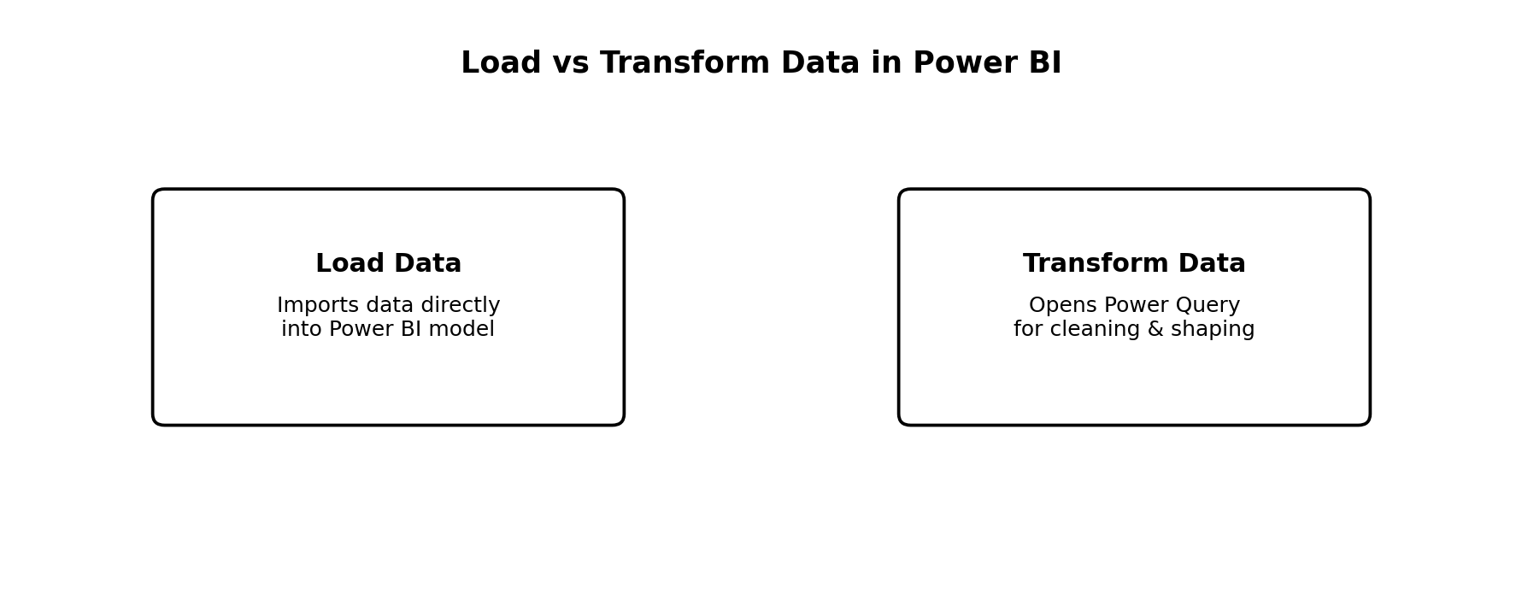
Figure 4: Conceptual difference between direct loading and transforming data before loading
Option | Meaning | When to Use
Load Data | Imports the dataset directly into the Power BI model without opening Power Query first | Use only when the data is already clean and analysis-ready
Transform Data | Opens the dataset in Power Query Editor before loading | Use when data needs cleaning, formatting, filtering, splitting, or validation
In most real-world analyst projects, Transform Data is the better and more professional choice because raw data usually needs at least basic cleaning and validation before analysis.

7. Basic Power Query Cleaning Workflow
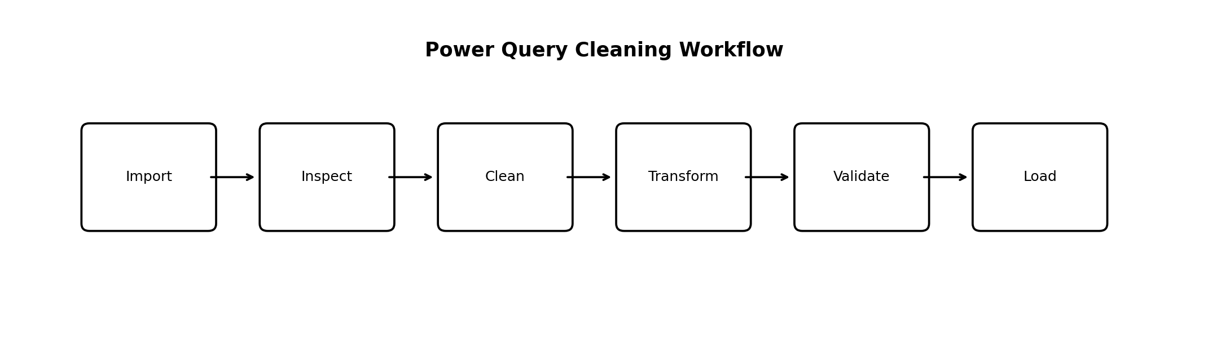
Figure 3: Typical Power Query cleaning workflow before loading data into Power BI
A good beginner workflow in Power Query is to first inspect the dataset, then clean text and data types, remove unwanted records, split or merge columns if necessary, validate results, and finally load the cleaned table into the Power BI model.

8. Basic Cleaning Tools in Power Query
- Remove Duplicates
- Remove Errors
- Remove Blank Rows
- Replace Values
- Change Data Type
- Split Column
- Trim
- Clean
- Format (uppercase, lowercase, capitalize each word)
- Extract values
- Merge Columns
- Fill Up / Fill Down
- Use First Row as Headers
- Rename Columns
- Remove Columns / Remove Other Columns

9. Remove Duplicates
Duplicate rows can inflate counts, distort KPIs, and create misleading analysis. In support ticket data, duplicate Ticket IDs can incorrectly increase total ticket counts and impact resolution metrics. Power Query provides a simple Remove Duplicates option to keep only unique values based on the selected column(s).

10. Remove Special Characters from Data
Special characters such as extra punctuation, symbols, hidden line breaks, tabs, and non-printable characters can create data quality issues, especially in text columns like customer names, email fields, ticket subjects, or ticket descriptions. Power Query provides multiple methods to handle this.
- Use Transform > Format > Clean to remove non-printable characters
- Use Replace Values to remove or replace unwanted symbols (e.g., #, %, @, extra spaces)
- Use Extract or Split functions when special delimiters are meaningful
- Use Text Select or custom transformations in advanced scenarios

11. Remove Unnecessary Columns and Rows
Not every imported column or row is useful for analysis. Unnecessary columns increase model size, reduce performance, and create confusion during report design. Unnecessary rows such as empty rows, subtotal rows, or irrelevant records can also negatively affect data quality.

12. Changing Data Types of Columns
Column Example | Correct Data Type | Why It Matters
Ticket ID | Text (or Whole Number depending on business use) | Avoid unwanted summation if ID is numeric-looking
Date of Purchase | Date | Required for time-based filtering and trend analysis
First Response Time | Decimal Number / Duration | Required for averages and comparisons
Time to Resolution | Decimal Number / Duration | Required for KPI calculations
Customer Satisfaction Rating | Whole Number / Decimal | Required for average satisfaction
Ticket Priority | Text | Used for categorical grouping

13. Splitting Columns in Power Query
Splitting a column means dividing one column into two or more separate columns based on a delimiter, fixed number of characters, or position. This is useful when raw data stores multiple pieces of information in a single field, such as 'City-State', 'FirstName LastName', or 'Category|Subcategory'.

14. Different Methods of Splitting Columns
Split Method | Use Case | Example
By Delimiter | Split using comma, space, hyphen, slash, etc. | Name-Surname, City-State
By Number of Characters | Split after fixed character count | Product code prefixes
By Positions | Split at specific index positions | Standardized IDs
Into Rows | Convert split values into separate rows | Multiple tags in one cell
By Left-most / Right-most Delimiter | Useful when delimiter appears multiple times | Email-like or hierarchical strings

15. Trim and Clean Data Columns
Trim removes leading and trailing spaces, while Clean removes non-printable characters such as hidden tabs and line breaks. These are among the most useful text-cleaning functions in Power Query.

16. Replace Null with Blank
Null values represent missing data in Power Query. In some columns, it may be appropriate to replace null with blank text or another default value. However, this should be done carefully because null and blank are not always equivalent in business logic.

17. Difference Between 'Remove Columns' and 'Remove Other Columns'
Action | Meaning | Best Use Case
Remove Columns | Deletes only the selected columns | Use when you know which columns are unnecessary
Remove Other Columns | Keeps only the selected columns and removes everything else | Use when you know exactly which columns are important

18. All Important Functions of Remove Rows and Keep Rows in Power Query
Function | Purpose | Typical Use
Remove Top Rows | Deletes a specified number of rows from the top | Remove extra header notes or metadata
Remove Bottom Rows | Deletes a specified number of rows from the bottom | Remove totals or footer text
Remove Alternate Rows | Deletes rows in a repeating pattern | Clean patterned exports
Remove Duplicates | Removes duplicate rows based on selected columns | De-duplicate tickets or records
Remove Blank Rows | Deletes fully blank rows | Clean messy spreadsheet imports
Keep Top Rows | Keeps only the first N rows | Testing or sample preview
Keep Bottom Rows | Keeps only the last N rows | Recent records or testing
Keep Range of Rows | Keeps rows from a starting index for a specified count | Subset analysis or validation

19. Format Functions in Power Query (Text Formatting)
Format Function | Purpose | Example
UPPERCASE | Converts all letters to uppercase | male → MALE
lowercase | Converts all letters to lowercase | FEMALE → female
Capitalize Each Word | Capitalizes the first letter of each word | ticket status → Ticket Status
Trim | Removes extra spaces at beginning/end | ' High ' → 'High'
Clean | Removes non-printable characters | Hidden line breaks or tabs removed

20. Additional Important Topics Added for Completeness
- Use First Row as Headers – Important when imported data has headers inside the first data row
- Rename Columns – Make names clean, readable, and report-friendly
- Filter Rows – Exclude invalid or irrelevant categories before loading
- Sort Values – Useful for quick validation, though not always necessary for the final model
- Fill Down / Fill Up – Useful when repeated group labels are stored only once in source data
- Merge Columns – Combine fields like First Name and Last Name when needed
- Extract Functions – Extract first characters, last characters, text before/after delimiter
- Applied Steps Discipline – Every change should be intentional and reviewable
- Preview Before Load – Always verify the transformed table before clicking Close & Apply

21. Best Practices for Week 2 Learning
- Always inspect column quality before applying transformations
- Change data types only after understanding the business meaning of each column
- Prefer Transform Data over direct Load in real-world projects
- Use Remove Other Columns when you want to keep only the required fields
- Be careful while replacing nulls; do not change business meaning
- Document every important cleaning step for transparency
- Check Applied Steps regularly to avoid accidental transformations
- Validate row counts before and after major cleaning steps

22. Week 2 Learning Summary
Week 2 was focused on building practical capability in Power Query, which is one of the most important tools for data preparation in Power BI. The week covered the introduction to Power Query, understanding different data import methods, learning the difference between direct loading and transforming data, and practicing essential cleaning operations such as removing duplicates, handling special characters, removing unnecessary rows and columns, changing data types, splitting columns, using Trim and Clean, replacing null values appropriately, and understanding the difference between removing selected columns versus keeping only selected columns.

23. Conclusion
Week 2 transitioned the internship learning from theory into practical data preparation. The focus on Power Query is highly important because every professional dashboard begins with a clean, well-structured, and validated dataset. By learning import methods, understanding when to transform data, and practicing core cleaning functions, a strong foundation has been built for the next stages of the project such as data modeling, KPI creation, and dashboard development.

